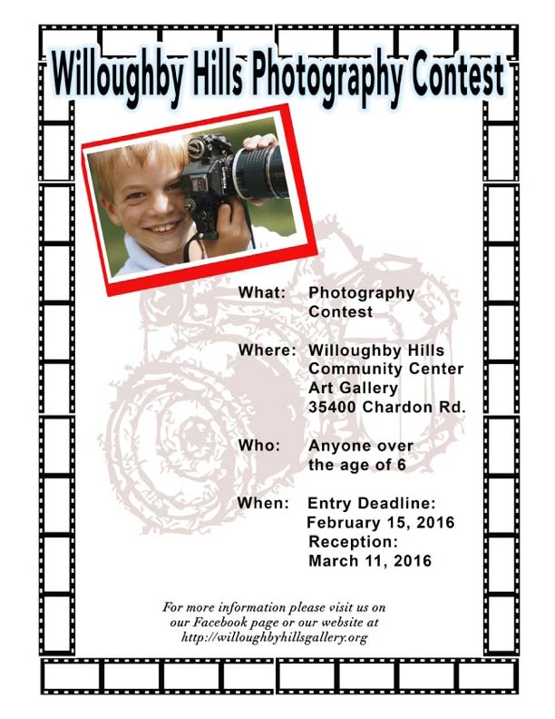
Willoughby Hills Photography Contest 2016
Photographers Entry Form
Our Mission: To encourage and promote the Arts within the Community of Willoughby Hills.
Eligibility: This show is open to all photographers age 6 and above. NO ENTRY FEES
Entry:
Photographers (16 - and above) are welcome to submit no more than three entries per person.Junior Photographers (ages 6 - 15) may submit one entry. All entrants are invited to the reception and prize ceremony on MARCH 11, 2016 7:00 PM - 9:00 PM at the Willoughby Hills Community Center 34500 Chardon Rd. Willoughby Hills
Winners must attend the reception to receive prizes.
Awards:
Ages 6 - 15 will receive ribbons of participation and be featured on the “Junior Photographers Wall”
16 and over qualify to win:
Best in Show - Apple IPadFirst Place in each category - A Kindle FireHonorable Mention Ribbons awarded for each category * Limit one prize per person
Categories:
Life in Willoughby HillsPets / Animals Nature PeopleBlack and White Junior Photographers (age 6 to age 15)
Juniors Photographers:
Categories:
Junior Photographers may submit one photograph they feel bestrepresents their talent.
Willoughby Hills Community Center Art Gallery reserves the rightto deny contest entry for any photograph submittedthat does not maintain Gallery standards.
Preparing Entries:
Photographs printed 8x10 inches
Framing:
All entries must be matted and framed similar to the frame shown below. Black frame, white matt. The frame should accommodate an 8x10 photograph and measure 11x14 inches. NO table top frames or plastic frames will be accepted, wall hanging frames only. Frameexamples can be viewed at Willoughby Hills City Hall.
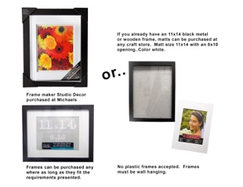
D-Rings:
D-Rings are available at WilloughbyHills City Hall or for purchase at anyhardware store. Two D-Rings must be screwed to the back of your frameso that your photograph can be hung.
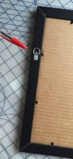
Preparing Labels:
Each entry must be labeled with an identiﬁcation tag (provided as part of this entry form).Forms must be completely ﬁlled out. Labels should be secured to the upper left corner on the back of the frame.
Digital Files:
Winning entries will be asked to supply a digital ﬁle for the purpose of furthering the Willoughby Hills Community Center Art Gallery and for the production of a gallery calendar highlighting this event. Calendars will be available for sale. Junior Photographers (ages 6 - 15) must submit digital ﬁles with name, phone number, and Willoughby Hills Photo Contest tolee@whccag.com
Delivery and Pickup Location:
Willoughby Hills City Hall 35405 Chardon Rd, Willoughby Hills.
Delivery Dates:
February 1, 2016 through February 15, 2016 8:00 am - 4:30 pm Monday through Friday.
Pickup Date:
May 3, 2016 8:00 am - 4:30 pm Monday through Friday.
Willoughby Hills will make a reasonable effort to contact artists for photographs not picked upwithin one months time. Items not claimed after one month become the property of Willoughby Hills.
Copy Rights:
All artists are responsible for obtaining proper copy rights prior to submission of photographs for exhibit.
Final Rule:
It is our sincere hope that everyone that joins in this event will enjoy their evening with us as we admire, participate, learn, and grow as artists. Good Luck to all.
For more information: Lee Tobin Re: Willoughby Hills Photo Contestlee@whccag.com
